1.Each Car brand How many car

Solution Query

SELECT 'audi' AS brand, count(Distinct ID) AS count_of_Car FROM audi1

UNION ALL

SELECT 'bmw', count(Distinct ID) FROM bmw1

UNION ALL

SELECT 'hyndai', count(Distinct ID) FROM hyndai1

UNION ALL

SELECT 'merc', count(Distinct ID) FROM merc1;

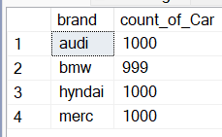

1. Categorize the cars on the basis of their price(Create as many buckets as you want as per your understanding of data) and analyze the:

OR

Brand Wise highest_price Compare Each other

Solution Query

SELECT

(SELECT MAX(price) FROM audi1) AS audi_highest_price,

(SELECT MAX(price) FROM bmw1) AS bmw_highest_price,

(SELECT MAX(price) FROM hyndai1) AS hyndai_highest_price,

(SELECT MAX(price) FROM merc1) AS merc_highest_price;

OR

SELECT 'audi' AS brand, MAX(price) AS highest_price FROM audi1

UNION ALL

SELECT 'bmw', MAX(price) FROM bmw1

UNION ALL

SELECT 'hyndai', MAX(price) FROM hyndai1

UNION ALL

SELECT 'merc', MAX(price) FROM merc1;

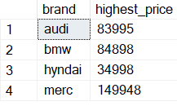

3.Each car brand find no of car use of type of fuel

Solution Query

SELECT

COALESCE(audi.fueltype, bmw.fueltype, hyundai.fueltype, merc.fueltype) AS fueltype,

COALESCE(audi.brand, 'Audi') AS audi_brand, COALESCE(audi.audi_Id, 0) AS audi_Id,

COALESCE(bmw.brand, 'BMW') AS bmw_brand, COALESCE(bmw.bmw_Id, 0) AS bmw_Id,

COALESCE(hyundai.brand, 'Hyundai') AS hyundai_brand, COALESCE(hyundai.hyundai_Id, 0) AS hyundai_Id,

COALESCE(merc.brand, 'Mercedes') AS merc_brand, COALESCE(merc.merc_Id, 0) AS merc_Id

FROM

(SELECT 'Audi' AS brand, COUNT(audi1.ID) AS audi_Id, fueltype.fueltype

FROM audi1

JOIN fueltype ON audi1.fuel_ID = fueltype.fuel_ID

GROUP BY fueltype.fueltype) AS audi

FULL OUTER JOIN

(SELECT 'BMW' AS brand, COUNT(bmw1.ID) AS bmw_Id, fueltype.fueltype

FROM bmw1

JOIN fueltype ON bmw1.fuel_ID = fueltype.fuel_ID

GROUP BY fueltype.fueltype) AS bmw

ON audi.fueltype = bmw.fueltype

FULL OUTER JOIN

(SELECT 'Hyndai' AS brand, COUNT(hyndai1.ID) AS hyundai_Id, fueltype.fueltype

FROM hyndai1

JOIN fueltype ON hyndai1.fuel_ID = fueltype.fuel_ID

GROUP BY fueltype.fueltype) AS hyundai

ON COALESCE(audi.fueltype, bmw.fueltype) = hyundai.fueltype

FULL OUTER JOIN

(SELECT 'Mercedes' AS brand, COUNT(merc1.ID) AS merc_Id, fueltype.fueltype

FROM merc1

JOIN fueltype ON merc1.fuel_ID = fueltype.fuel_ID

GROUP BY fueltype.fueltype) AS merc

ON COALESCE(audi.fueltype, bmw.fueltype, hyundai.fueltype) = merc.fueltype;

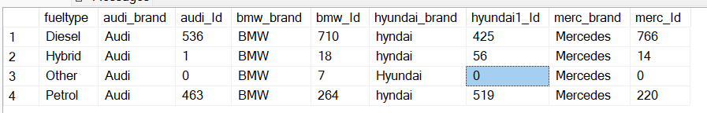

4.price changes across the years and identifies the categories which have seen a significant jump in their price

OR

Each car brand yearly wise highest price

Solution Query

SELECT 'audi' AS brand, year, max(price) AS year_wise_highest_price FROM audi1

group by year

UNION ALL

SELECT 'bmw', year, max(price) FROM bmw1

group by year

UNION ALL

SELECT 'hyndai', year,max(price) FROM hyndai1

group by year

UNION ALL

SELECT 'merc', year,max(price) FROM merc1

group by year;

Or

SELECT top 5 'audi' AS brand, model_name,year,max(price) AS year_wise_highest_price FROM audi1 join models

on audi1.model_ID=models.model_ID

group by model_name,year

UNION ALL

SELECT top 5 'bmw',model_name, year, max(price) FROM bmw1 join models

on bmw1.model_ID=models.model_ID

group by model_name,year

UNION ALL

SELECT top 5 'hyndai',model_name, year,max(price) FROM hyndai1 join models

on hyndai1.model_ID = models.model_ID

group by model_name, year

UNION ALL

SELECT top 5 'merc', model_name,year,max(price) FROM merc1 join models

on merc1.model_ID= models.model_ID

group by model_name,year;

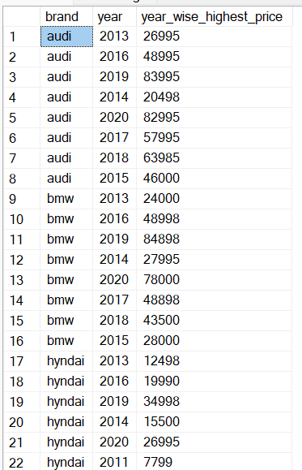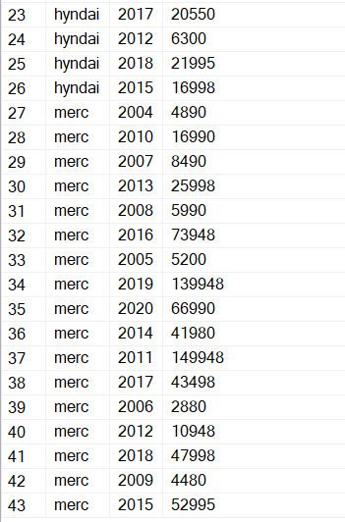

Or

SELECT top 5 'audi' AS brand, model_name,year,max(price) AS year_wise_highest_price FROM audi1 join models

on audi1.model_ID=models.model_ID

group by model_name,year

UNION ALL

SELECT top 5 'bmw',model_name, year, max(price) FROM bmw1 join models

on bmw1.model_ID=models.model_ID

group by model_name,year

UNION ALL

SELECT top 5 'hyndai',model_name, year,max(price) FROM hyndai1 join models

on hyndai1.model_ID = models.model_ID

group by model_name, year

UNION ALL

SELECT top 5 'merc', model_name,year,max(price) FROM merc1 join models

on merc1.model_ID= models.model_ID

group by model_name,year;

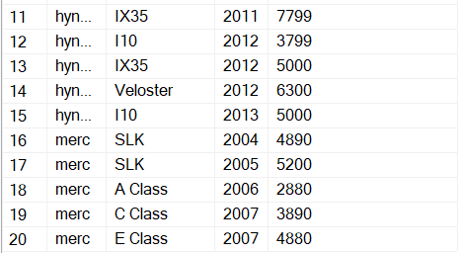

1. Brand wise total revenue

Solution Query

Select 'auidi'As brand,

sum(price) As revenue from audi1

union all

Select 'bmw'As brand,

sum(price) As revenue from bmw1

union all

Select 'hyndai'As brand,

sum(price) As revenue from hyndai1

Union all

Select 'merc'As brand,

sum(price) As revenue from merc1

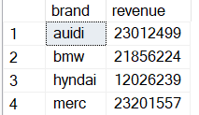

1. Brand and yearly wise total revenue

Solution Query

Select 'auidi'As brand,year,

sum(1*price) As revenue from audi1

group by year

Union all

Select 'bmw'As brand,year,

sum(1*price) As revenue from bmw1

group by year

union all

Select 'hyndai'As brand,year,

sum(1*price) As revenue from hyndai1

group by year

union all

Select 'merc'As brand,year,

sum(1*price) As revenue from merc1

group by year

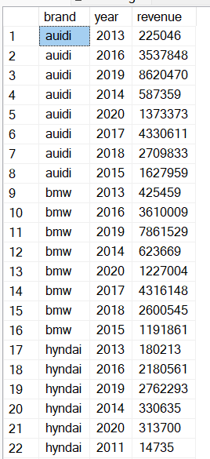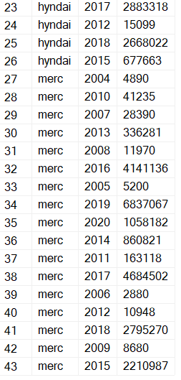

7.Brand according highest mileage with year and ID

Select 'Auidi' as BRAND, ID, year, mileage from audi1 where mileage=

(Select max(mileage) from audi1)

Union all

Select 'BMW' as brand, ID, year, mileage from bmw1 where mileage=

(Select max(mileage)from bmw1)

Union all

Select 'HYNDAI' as brand, ID, year, mileage from hyndai1 where mileage=

(Select max(mileage)from hyndai1)

Union all

Select 'MERC' as brand, ID, year, mileage from merc1 where mileage=

(Select max(mileage)from merc1)

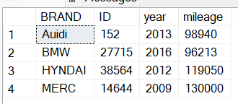

8.How many car brand type of transmission

Select'auidi' as brand, transmission ,count(audi1.ID) as brand_count from audi1 join transmission

ON audi1.transmission_ID= transmission.ID

group by transmission

Union all

Select 'bmw' as brand, transmission ,count(bmw1.ID) as brand_count from bmw1 join transmission

ON bmw1.transmission_ID= transmission.ID

group by transmission

Union all

Select 'hyndai' as brand, transmission ,count(hyndai1.ID) as brand_count from hyndai1 join transmission

ON hyndai1.transmission_ID= transmission.ID

group by transmission

Union all

Select 'merc' as brand, transmission ,count(merc1.ID) as brand_count from merc1 join transmission

ON merc1.transmission_ID= transmission.ID

group by transmission

